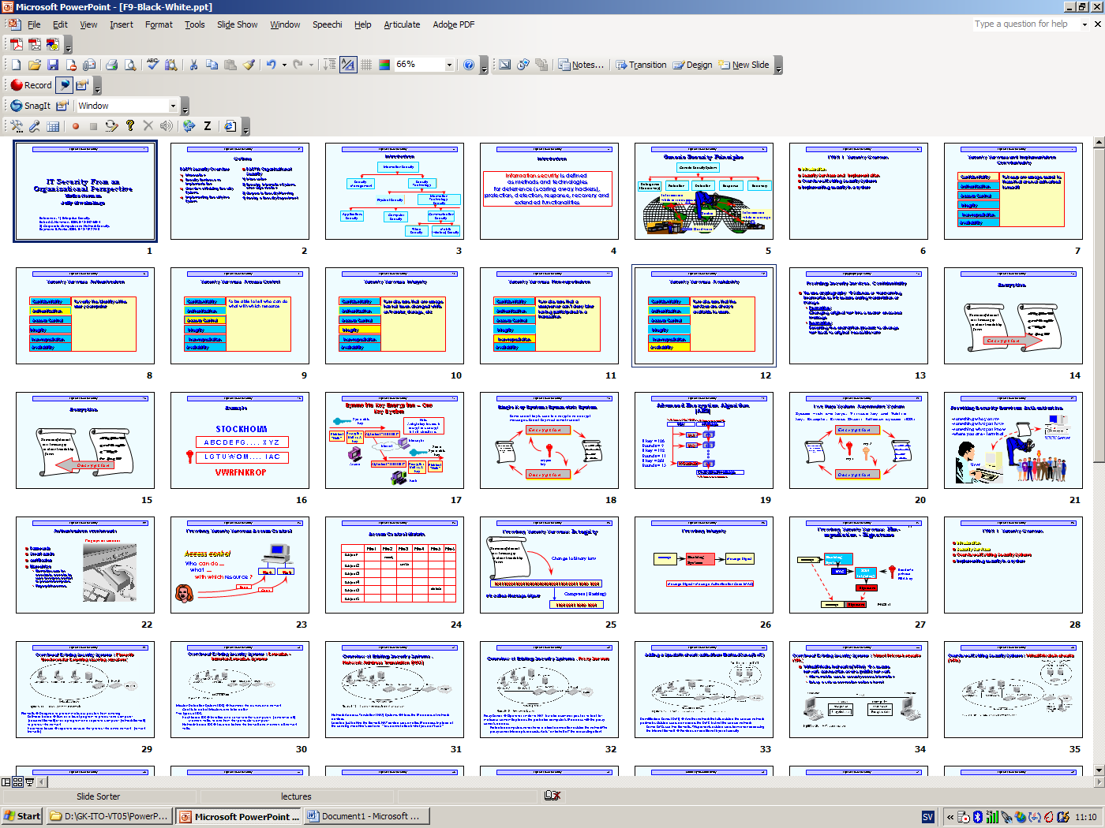

To convert these colored slides to black and white for easy printing: go to Tools in the Microsoft’s power point window. Then choose options; you will come to the tool shown below. Check the boxes as displayed in that tool and save to a new file.

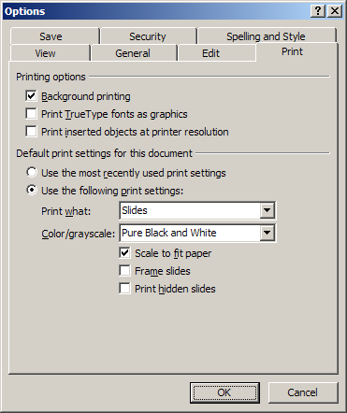

We have to convert it to PDF format in black and white. To do this we choose File and then print Adobe PDF printer. Then choose in the color/grayscale Pure Black and White.

