Innehåll

**The User** 2

**The World** 2

Interaction Design 4

HCI 4

**Design principles** 5

Mental models 5

The Users’ language 6

Settings 6

Game settings 6

**Setting comparison between genres** 8

Support User Interface 11

Immersion 11

The gamer 12

A summary of the problem 13

Methods 14

First data collection 14

Application 14

Application 16

Weaknesses of methods 16

First data collection 16

Second data collection 17

Results 19

Results and analysis of the first data collection 19

Results and analysis of the second data collection 21

Discussion 23

References 29

Ludography 32

Appendix 33

Abstract

When gaming researchers are using HCI they are, usually, looking at game mechanics and game interaction. As a settings menu in games works more like a menu in other software HCI can be used in a more traditional way than mostly used in other games studies.

The core of this article lies in PC-games settings menu. The settings menu exists to help the gamer to get as good gaming experience as possible within the constraints of the gamers hardware and preferences.

Even with all the research done in games little research is done about a games settings menu, or even individual settings. As the settings can have an impact on the users game experience they need to be understood to be used. If they are not understood it means that the users are either guessing or ignoring the settings. This can have an adverse effect on the immersion of the game, making it less enjoyable.

Game settings are often represented by technical terms that are seldom used outside of games. There are reasons for this but it does not help the user to understand them. This means that a user would have to have expert knowledge about game settings to make an informed choice, a knowledge that does not have much use outside of games.

This study looked at how well the users understood the settings and how well they could solve problems connected to these settings, in games.

The purpose of this paper is to find out if there is a need for more information and/or a change in terminology so that a person have the possibility to make an informed choice when they are trying to make changes in a games settings menu. This is done by first checking if the users can understand the terms used for game settings with a questionnaire. Secondly an observation, with a follow-up interview, will check to see if the users can identify and correct an incorrectly set setting.

The findings in this paper is that users mostly change graphic settings, but tend to not understand the terms used.

Background

**The User**

As a study from Interactive Software Federation of Europe (ISFE, 2012) shows, a large amount of people in Europe are playing games. In the age span 16-44 more than 50% are playing games.

Looking at sales figures from the nordic countries, you can see that the amount of games sold, increased over 100% between 2006 (Dataspelsbranchen, 2006) and 2010 (Dataspelsbranchen, 2010, a). This includes PC games, console (PS3, XBox 360 and Nintendo Wii) and portable (PSP, Nintendo DS and such). The figures that are brought up in the reports above does not cover games on smartphones or tablets and even though we could assume that people are also playing on those platforms, we do not consider them in this report.

Jesper Juul (2009) writes in “A casual revolution” that , for some gamers the “casual game” design could be a gateway to videogames. With video games Juul refers to all kinds of computer games and console games. Juul states that videogames are leaning more towards being “hardcore” games. The terms “casual” and “hardcore” are often used to describe how much time and effort a gamer put in to his/her gaming. “Hardcore” gamers are said to put more time and effort into their gaming than a “casual” gamer does. These terms are sometimes interpreted after what kind of games the gamer are playing. This means that it is sometimes considered, according to Juul, that certain genres of games fall within these two concepts, and that a user can not be hardcore if he plays casual games. As the number of players is growing quickly these concepts are blurred more and more and the concepts themselves are not especially precise.

The term gamer is used in this study. It can have different definitions but in this paper it is defined as a person using a computer game more or less regularly. The “average gamer” can be hard to define, as shown above, but in this paper it is needed to have an idea of the level of technical knowledge gamers have. As, also, shown above, a lot of people play games and they are of varied age. This lets us conclude that the level of technical knowledge of the average gamer is close to that of the average person. When designing a system it is important that the average user can understand how it works, and the terms used in it. Without this understanding it would be very hard for a user to make any meaningful interactions with a system.

**The World**

When a user interacts with a system he or she creates a *mental model* for how the system works (Gentner & Stevens, 1983). This model is updated every time the user interacts with the system. The model does not have to be correct to be functional. This means that a user may not understand the system but can still use the system. When faced with a new situation with the system, or another system, an incorrect model may cause user error and lead to frustration.

If a system does not use terms that the user understands it is near impossible for that user to create a functional mental model for the system. A computer system is not built in a way so that a normal user understands how it actually functions. Because of this it is important that the developer takes care to present information in a language that the user understands. This is called the *users’ language* (Nielsens, 1994). When a user does not understand the terms used by the system there is a mismatch between the users expectations, or mental models, and the functionality of the system. This mismatch is a cause for user error and frustration.

It is difficult for a user to interact with a system they do not understand and the users’ language plays a big part in helping the user with this. There are many other aspects of a system that makes it easier, or harder, for a user to interact with it. These aspects are handled by the field of Human-Computer Interaction (HCI) that not only researches exactly what these aspects are but also develops techniques to help develop a system that is easier to interact with. HCI falls under another, wider, field that is called Interaction design which handles pretty much what it is called; how to design well with interaction in mind. This field is built on principles from many different fields of science, such as HCI, Psychology, Cognitive Science and Informatics. By using principles designed through HCI and/or Interaction design it is easier to avoid making a system that is hard to interact with. This in turn means that a user will encounter fewer problems and, hopefully, be more at ease with the system.

One good way of making a system behave more like the user wants is to allow the user to change the behaviour of the system. Some systems, like computer games, will also behave differently on different computers which almost requires that the user will be able to change the systems behaviour. This is commonly done through its *settings*. The settings is usually presented in an interface designed just for this purpose and is usually shown in the form of different choices represented by terms that relates to changing specific behaviours of the system. These terms can sometimes be explained with further text or images to help the user understand what they mean.

It is important that the terms used at least tries to speak the users’ language. If it does not a user will not be able to understand the choices and then can not make informed decisions when changing settings. It may even lead to the user not daring to change settings or guessing what settings to change and getting it wrong, which could very well lead to new problems.

The choices that are being shown relates, as already stated, to specific functions that changes specific behaviours of the system. These choices can come in many form, depending on the nature of the setting. They range from simple Yes/No choices to multiple choices. The exact form of the choice depends largely on what the designer feels appropriate but drop-down menus or checkboxes are common. What alternatives for the choice that the user gets to see is limited by the developer to those choices that makes sense, and is safe, for that particular function. One example for this could be mouse movement speed that a user can change. A developer would naturally define the upper and lower boundaries for this setting since if its set too high it will be near impossible to interact with and the same goes for if it is set too low, or even negative.

In this study computer games settings will be used. Computer games settings tend to be more technical since they are based on advanced computations and techniques. As computer games are primarily used for entertainment it is unreasonable that the user is expected to understand technical terms. Software used in a working environment can use technical terms as the intended users are expected to have enough technical expertise.

The problem in this study is that, we believe,  the average user can not make informed choices when changing settings. In other words the user will encounter a problem that he or she in turn can not solve. It is this second problem, that the user can not solve their own problem through changing settings, that we are interested in.

This study will *not* try to find a solution for this problem, instead it tries to define the problem and the consequences caused by the problem. Solving the problem is left for further studies as there can be many different solutions of various degree of effectiveness.

Extended Background

Interaction Design

“Interaction design relies on an understanding of the capabilities and desires of people and on the kinds of technology available to interaction designers, as well as a knowledge of how to identify requirements and evolve them into a suitable design.” Preece, Rogers & Sharp (2009)

Interaction design is built on lots of different science fields as can be seen in the figure below.

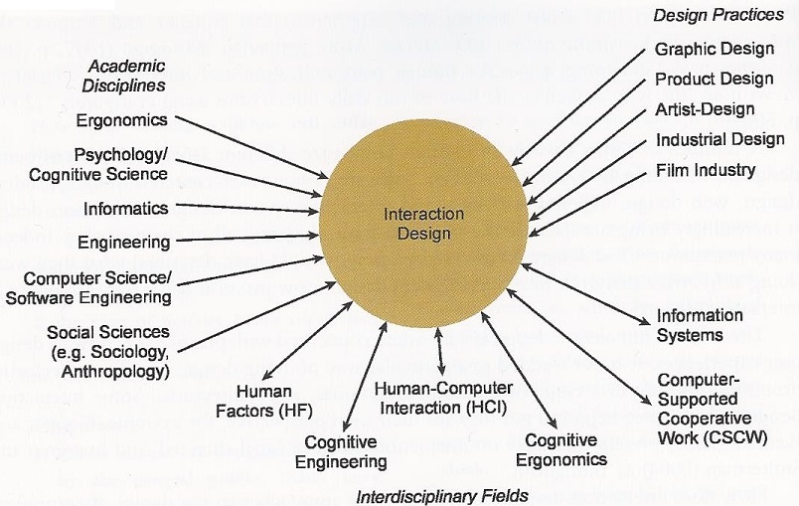

Figure 1. The different fields of Interaction design.

The goals for interaction design can be described as “easy to learn, effective to use and providing an enjoyable user experience.” Preece, Rogers & Sharp (2009)

HCI

Human Computer Interaction (HCI) is about designing so that the user can make an informed choice when interacting with computers. It is also about evaluating systems already built to ascertain how easy the systems are to use. Through HCI many tools, to help with developing systems, have been created. These are, generally, aimed to help the developer make the system more user friendly. Other tools created, through HCI, are aimed to evaluate systems and compile the problems found in a way so that the developers get a good overview of them.

**Design principles**

D. Norman (2002) states that the intention of design should:

* “Make it easy to determine what actions are possible at any moment (make use of constraints).”
* “Make things visible, including the conceptual model of the system, the alternative actions, and the results of actions.”
* “Make it easy to evaluate the current state of the system.”
* “Follow natural mappings between intentions and the required actions; between actions and the resulting effect; and between the information that is visible and the interpretation of the system state.

For our purpose, this can be interpreted to:

1. The user can understand the choices that are available.
2. The user can understand what the choice entails.
3. The user understands the consequences of the choice.

What choices are available is often limited by that the system only provides the choices that are technically possible. What the implications and consequences of these choices are can be more problematic if the user lacks experience with the system or sufficient technical expertise. According to D. Norman what the system should do to alleviate this problem is to somehow explain what impact a choice will actually have. As many systems are built on techniques that can be hard to conceptualize, for a user without technical expertise, this can cause user errors and frustration.

Mental models

When a user conceptualizes a system he or she creates a mental model of how it works. Mental models develop naturally when a user interacts with a system (Gentner & Stevens, 1983). These models needs to be functional to be usable but do not have to be technically correct. This means that a user can have a functional model over how a system works, and thus be able to use this system, that is technically incorrect. The model is furthered developed through continued interaction with the system, or a similar system. These models are carried over to other systems and if they are not correct may cause a result that is different between systems. What happens then is that a user can have developed a functional, but incorrect, model for how a system works and then applies that model for a similar system but in the second system this model is *not* functional. If the model would have been correct from the start it would have also been functional in the second system.

Systems can be put into different categories based what they are supposed to be used for. Some examples could be: web browsers, text editors, computer games, media players, e.t.c. The amount of categories are almost endless as you can usually break down a category into several more categories and so on. An important aspect of this is that systems belonging to the same category, usually, have some similarities in purpose, and quite often in how they are designed. Some systems are even built from the same framework and thus have very much in common. A good example of this is *game engines* (Gregory, 2009), which are software that game developers often use to build their games on instead of starting from scratch. This is often done because it can be cost effective to start with a base and build on that. All this means that mental models for a system will be more effective for other systems in the same category than those from other categories. Even with this is mind there is a chance that a model will simply not work between systems, even if they look similar or uses the same terms.

The Users’ language

For a user to be able to create a functioning mental model it is beneficial if the system speaks *the users’ language*. One of Nielsens (1994) usability heuristics, called “Match between system and the real world”, explains this: “The system should speak the users' language, with words, phrases and concepts familiar to the user, rather than system-oriented terms. Follow real-world conventions, making information appear in a natural and logical order.”. It has been shown in studies (Rimmer & Wakeman, 1999) that mismatched language is a cause for frustration and a cause of a negative user-experience. Beyond that a company would need greater support for the system to handle the problems caused by this mismatch. It has also been shown (Rimmer et al, 2002) that there is a mismatch between the knowledge and the *expectations* of the user and the language of the system. These expectations are the model that a user have created for the system and the mismatch is because the model is incorrect.

Settings

It is common that a system will allow a user to change its behaviour based on many different reasons. These reasons varies a lot depending on what kind of system that is used but common examples are: personal preference, language, hardware, interactions with other systems, e.t.c. When a user changes how a system behaves it is usually done via various settings that are commonly presented in its own interface. This interface can take many forms but it is common that it is presented as some sort of menu with the different settings, or choices, mapped to various terms, describing the relevant choice. K. Norman (1991) writes that the purpose of a menu is to convey information containing the character of the choice (what is the purpose of the choice) and the character of the alternatives (what is the consequence of the alternative). To achieve this the menu must be careful to use language that a normal user can understand. A normal user can vary quite a lot depending on what the system is supposed to be used for. For example a system for software development can use quite technical terms, as the normal user will be a software developer, whereas a web browser needs to take much more care to not use technical terms, as the normal user can not be assumed to have that much technical expertise.

## Game settings

Settings in computer games usually share some similarities and is usually divided into several groups, with each group changing the behaviour of a certain sub-system. Among these groups it is very common to find settings for sound, settings for input and settings for graphics. This is all very logical because almost all PC-games are interactive and audiovisual software. Beyond these settings another common one is a more game-specific group. What settings exists in this group varies quite a lot.

The reasons these settings exists in the first place are many. For PC-games a major reason is that the hardware in PC’s vary (Valve, 2012). This means that a set of predefined settings will not always work as well as they should. These problems can be as simple as the mouse being too sensitive or as complex as the game having too low frames per second and feeling jerky. The last problem is very closely tied to the PC’s hardware as having more powerful hardware would solve the problem but changing the settings could very well solve it too. One problem here is that the user would need good knowledge of exactly what hardware exists in his or her computer and also good understanding of the consequences of the relevant settings. Beyond that the terms used for the settings are often quite technical as well, making it even harder to make a rational choice.

Another reason to change settings is simply personal preference. The game may just be more enjoyable with small changes that suits a gamer’s need, or environment for that matter.

One very important reason to be able to change settings is accessibility for people with different disabilities. There are a few organizations working to get more game developers aware of this issue, f.ex. the International Game Developers Associations special interest group Game Accessibility, and there is even a fairly comprehensive list (Game accessibility guidelines) compiled by various people in the game industry. A couple of examples of settings that helps a lot with this is allowing a user to re-map input keys and a setting for color-blind people. The first one is good because people with impaired motor skills that require some specialized input controls can also use the game and the last one is good because many games give the user information in the form of colors. Many of these settings are also quite useful for people without disabilities and several can usually be found in games, f.ex. allowing a user to remap keys.

A problem with game settings is that they can be hard to map to real world concepts. As the game is in itself constructed by various, and usually advanced, techniques a suitable metaphor for this technique may not exist in the real world. It can, in other words, be quite difficult to try to use the users language. A good example of this is *Anti-aliasing*. The best way to explain this technique is to explain the actual problem, aliasing. This is an effect you get in computer graphics where the edges of objects appear jagged. This is due to they way computer graphics is built on pixels which means that slanted edges can not be completely smooth because the edge is built by stacking blocks. What anti-aliasing does is to lessen this effect as much as possible. When applying the setting you can usually decide the amount, or passes, of anti-aliasing at the cost of needing more computing power.

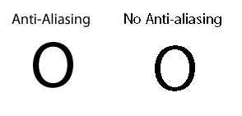

Figure 2. For more illustrated examples see the entry on anti-aliasing on Wikipedia (<http://en.wikipedia.org/wiki/Anti_aliasing>).

This problem does not exist in the real world because it is specific for computer graphics. It is therefore hard to map the setting to the real world.

The *idea* of the setting a user may want to change can be very simple but the technical implication in the game may be very complex. An example of this could be that the user wants his or her character to move faster. The conceptual idea is very simple but the technical implementation can be *very* advanced, depending on how the game is constructed. Increasing the movement speed would mean changing a lot of different things that generally go unnoticed, like animation speed, camera settings, e.t.c. In some games its not even the character that moves, its the world that moves and the character stays put. This is usually not what the user sees when playing the game but it is how the game works from a technical standpoint. The reason it works like this is that games are simulations and thus uses techniques that may appear to the user to function quite like the real world but in reality functions in a very different way. For example gravity in games does not automatically mean that objects are drawn to bigger objects, or more commonly fall down. It could just as well be the *world* moving up instead of the object moving down. All this means that it can be very hard to conceptualize a setting in a simple term and maybe even harder to explain the consequences of that setting.

**Setting comparison between genres**

Even though games differ greatly between genres the settings a user can change are usually quite similar. The design of the interface varies a lot as the game generally tries to keep a uniform, and unique, design throughout the game. The terms used for the various settings can differ between games as well but in general they are, somewhat, similar.

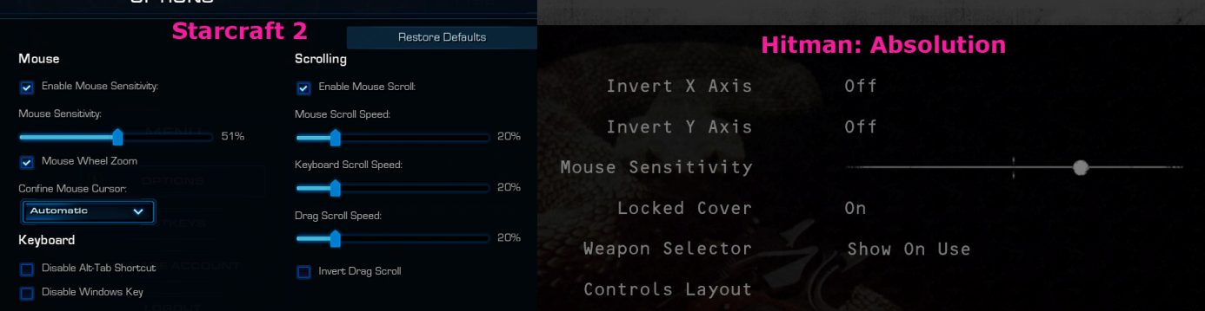

Figure 3. Input settings in Starcraft 2 & Hitman: Absolution.

This image shows the input settings for Starcraft 2 (Blizzard Entertainment, 2010) and Hitman: Absolution (Io Interactive, 2012). It does not show the keymapping, as that usually contains mostly game specific settings. The image shows some game specific, or genre specific, setting. There is two in Hitman; Locked Cover and Weapon Selector. The whole right part of the Starcraft 2 input settings is genre specific and has to do with scrolling over the map. As Starcraft 2 is a Realtime Strategy game (RTS) you have a top-down view of a playing field and because of that you need to be able to scroll around on the map. Hitman on the other hand is a action-adventure stealth game with a third-person view. This means that a mouse cursor is rarely seen in Hitman, which in turn means that the setting Confine Mouse Cursor, in Starcraft 2, is of no use. The two settings under that one (Disable Alt-Tab Shortcut and Disable Windows Key) are still relevant in Hitman but for some reason the developers chose not to add these. It should be noted that these settings are not very common in games. There is one setting that shows up in almost all games (at least all games using a mouse for input) and that is the Mouse Sensitivity setting. This controls how fast the mouse cursor moves. In Hitman there are two settings for inverting the mouse movement (Invert X Axis and Invert Y Axis). These are also common in some types of games (depending on the view the game offers) but is usually shown as one setting, called Invert Mouse or something similar.

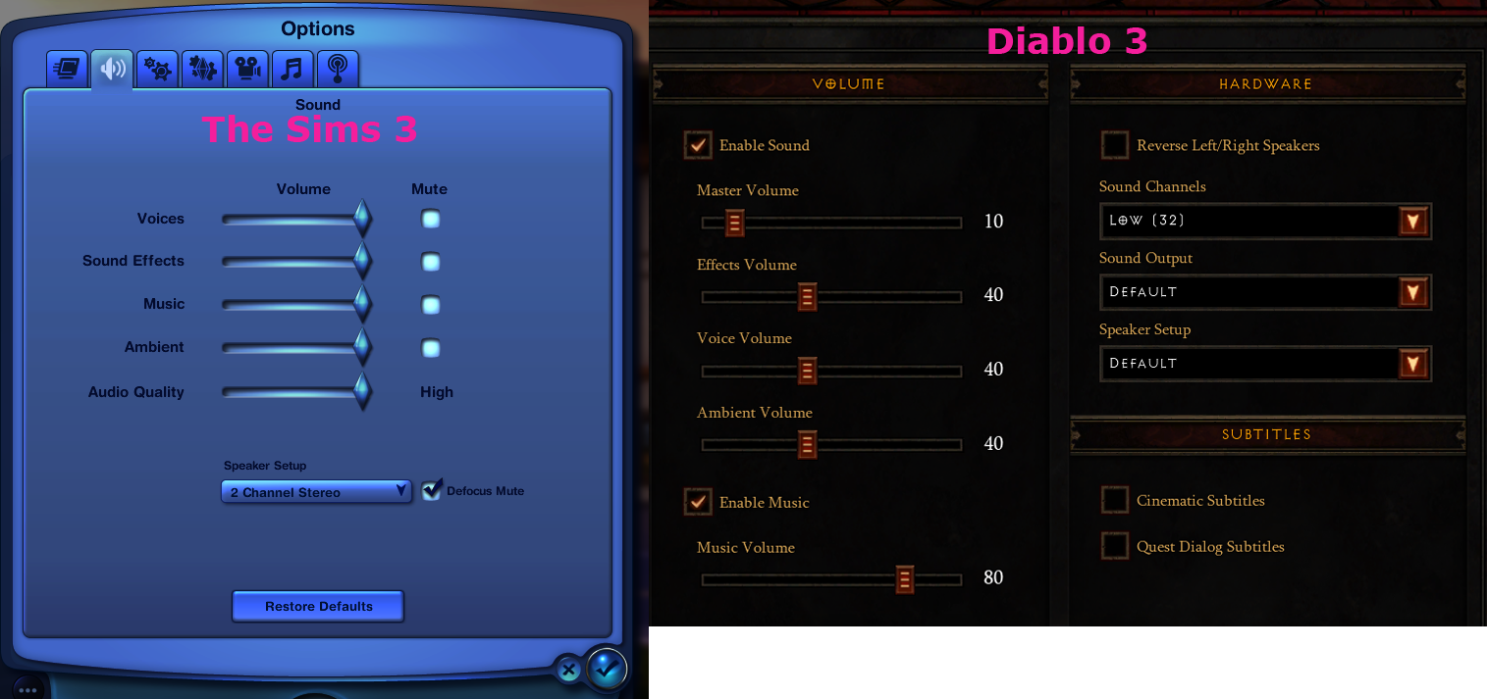

Figure 4. Sound settings in The Sims 3 & Diablo 3.

This image displays the sound settings interface for The Sims 3 (Simulator) (The Sims Studio, 2010) and Diablo 3 (FPS) (Blizzard Entertainment, 2012). The Sims 3 is a slow paced game simulating one, or many, persons everyday life. Diablo 3, on the other hand, is a fast paced action game where you fight against hordes of demons. Even though the games are quite different the settings are similar. Sound settings usually include one or several sliders that controls the volume of different sounds in the game. Common ones are music and sound effects. As can be seen in the image both games have these (although it is simply called “Effects” in Diablo 3). Other similarities is ambient and voice volume and these are very common as well but some games does not have voices, for example. There are one other setting that is directly comparable and that is the speaker setup option. Another setting that may not seem to be the same, but in reality is, is the audio quality (in Sims 3) and the sound channels (in Diablo 3) setting. It is simply displayed in a less technical way in The Sims 3. The remaining settings in Diablo 3 are only applicable if the game uses subtitles, except for the sound output setting which is not uncommon in games. In many games there are even less alternatives and in some there are only one or two sliders, usually one for sound effects and one for music.

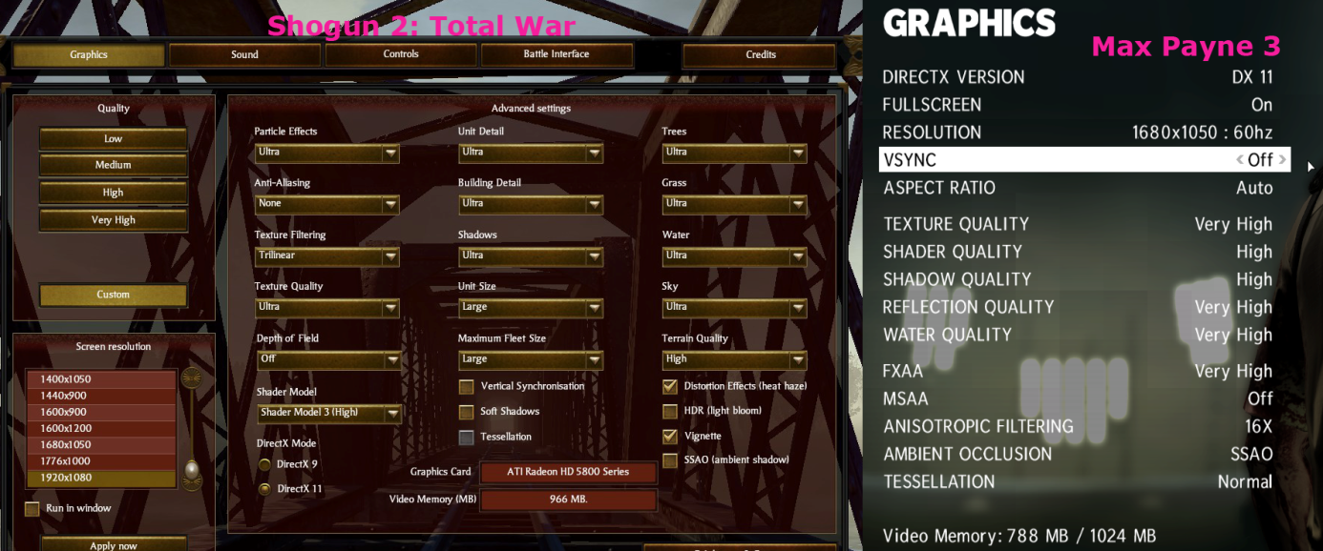

Figure 5. Graphics settings in Total War: Shogun 2 & Max Payne 3.

This image displays the graphics settings in Total War: Shogun 2 (The Creative Assembly, 2011) and in Max Payne 3 (Rockstar Studios, 2012). Shogun 2 is a turn based strategy game with real-time combat (similar to a RTS game) and Max Payne 3 is a action game where the view is over the shoulder of the player character. Although the design, and the way you change the setting, is very different between the games the actual settings are mostly the same.  The differences is mostly in the Shogun 2 interface and most of those settings (unit detail, building detail, unit size and maximum fleet size) are either game specific or genre specific. Other differences are not actual differences but rather design choices from the developer. The aspect ratio setting in Max Payne 3 is in itself not a setting, it just limits the options for the resolution setting. One setting that is the same but presented in a different way is the anti-aliasing option in Shogun 2. On first glance this does not exist in Max Payne 3 but the FXAA and MSAA settings are actually two different techniques for anti-aliasing (FXAA is an acronym for Fast Approximation Anti-Aliasing and MSAA is an acronym for Multisample Anti-Aliasing). Another setting that seems to be different is shader quality in Max Payne 3. In Shogun 2 there is a setting called shader model which is the same, only the options for it is very different. Some settings does not exist in both games and this is mostly due to the view in which the player sees the game or the world the games are supposed to show. Good examples of this are the particle effects setting in Shogun 2 and the tesselation setting in Max Payne 3.

If you compare the different interfaces it is apparent that the graphics settings have more alternatives and that they are more often of a technical nature. It is also apparent that, even though the design and terms are different, the alternatives in different games are usually quite similar even between genres.

Problem

Support User Interface

Support User Interface (SUI) is a term that we use to describe an interface used to change the settings in a game. This interface is not really in-game because the user exits the game world to access it. There may be some games that lets you change these settings in-game but that is not the norm. We choose to use this term to make this distinction between in-game interfaces and the interface where you change game settings.

Immersion

When a setting is not correctly set a number of problems can occur. All of these problems means that the game behaves in an unwanted fashion, or an unexpected fashion. The specific problems can take many forms but all of them have an impact on the users game experience. When playing a game you enter what is commonly called the *magic circle* (Huizinga, 1955). The magic circle is a concept where the players steps into a magic circle when playing a game and accepts all the rules in this circle. The insides of the magic circle is disconnected from the real world in a way that means the actions conducted inside the circle has no impact on the “real world”. When changing a setting in a computer game the player have to step out of this magic circle and thus suspend the game. This breaks the so called *suspension of disbelief* (Rollings & Adams, 2003). This is a mental state where a person accepts the fiction, and the rules, of a game as reality. The better the game manages to maintain this illusion the more *immersive* the game becomes. And as Rollings & Adams writes “Immersiveness is one of the holy grails of game design”.

Another important aspect of immersion is the challenge of playing a game. Linderoth(2011) splits challenge in a game action into two categories: *exploratory challenges* and *performatory challenges*. Exploratory actions are when an execution of an action is simple but understanding when to use that action is challenging. Performatory challenges are just the opposite, performing the challenge is difficult but knowing when to use it is simple. If a game does not function correctly both of these challenges can become skewed. If the sound settings are badly set it can, for example, be very hard to understand when to perform a certain action. This example shows how an exploratory challenge becomes harder than it should. The same can be seen with performatory challenges. Say, for example, that the mouse sensitivity is set too low, and the mouse input is lower than intended, it can be much harder to perform an action than intended.

When the level of immersion is just right a user will achieve *flow*. This is a concept described well by Csikszentmihalyi(2008): “A state of mind when a player experiences a high degree of focus and enjoyment”. This state of mind is reached when the game provides the right amount of challenge for a user to be challenged but not so much that he/she will become frustrated. When a user reaches this state of mind he/or she will stop thinking about being separate from the game and accepts the “reality” of the game. Csikszentmihalyi also writes that while in this state of mind a user can lose self-consciousness, consciousness of the world and sense of time.

As a user continues playing a game the skill of the user will increase, in the scope of that game. This means that the challenge needs to increase at the right level for the user to maintain flow. According to Csikszentmihalyi if the challenge is increased too fast the user will become anxious but if it is increased too slow the user will become bored.

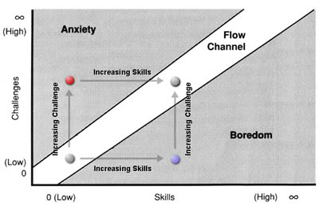

Figure . The Flow Channel.

If the settings in a game is set in a way that makes the game behave in a way that lessens the immersion the game experience of the user is lessened. It is obviously bad for the user if this happens but also for the game developer as the better the game experience is the more likely the game will be more popular. The solution to this problem is to change the setting to make the game behave the way that is wanted.

When changing a setting in a game a user leaves the actual game world and accesses the SUI. As already explained a system should facilitate easy use and understandable terms for the targeted user. As games are built on advanced computations that require a lot of computing power the settings in a game is very tightly balanced between audiovisual beauty and performance. This in turn means that a setting can have a great impact on the game itself when changed. If the setting, and its alternatives, are hard to understand correcting a problem will become very difficult. Many games uses names for rendering techniques or names of algorithms to represent different settings (see Appendix 1). Neither of these could be considered speaking a normal persons user language. This raises the question what the normal user for computer games are.

# The gamer

Defining a standard gamer is very difficult. Historically the view of a typical gamer is a adolescent male with interest in computers and IT. Later gamers tended to be categorized as either *hardcore* or *casual*. These terms where, and to some extent still are, used to describe how much time and effort a gamer puts into gaming. As Juul(2009) explains this is not very accurate as a gamer that considers him- or herself casual can spend a very large amount of times playing games and players considered hardcore does not have to play that much. The definition is, sometimes, also used to describe what type of game the gamers play. Hardcore gamers are then considered playing more games based on performatory challenges, and quite often against other humans, such as First Person Shooters. Casual players would then play more slow paced games based on exploratory challenges. This stereotype does not hold true for all games as there are some that could be considered casual and still be based on performatory challenges and vice versa. These definitions are not always accurate and defining a player as either casual or hardcore can sometimes be very difficult. Since it is so hard to define an average gamer it is hard to assume what level of expertise a user will have when designing a game’s settings menu.

It can also be hard to define a standard players age group, gender or nationality. As a study from ISFE (2012) shows, the people playing games in Europe are very diverse. They are spread fairly well between genders and age groups. The percentage of people playing games in the age group of 16-44 is more than 50% across all european countries. Over that age the percentage falls of and in the age group of 55-64 only 27% plays games. Even so it is apparent that a large part of the population of Europe plays games. This is not just true for Europe as in the United States of America the amount of gamers increased by 6.000.000 in 2009 (Sheffield, 2009) which is an increase from 58% (2008) to 61% of the U.S. population.

All this means that the standard gamer is very hard to define, so hard that it is practically impossible. Gaming is so usual today that a gamer can come from anywhere in a society. With so many gamers game development is also big business. The amount of games sold increases steadily. In the Nordic countries alone games sold have more than doubled between 2006 (Dataspelsbranschen, 2006) and 2011 (Dataspelsbranschen, 2011).

A summary of the problem

With a standard gamer being so hard to define it can be hard to create a SUI for a normal user but it is a safe bet to assume that the standard gamer has about the same technical expertise as the average person. In reality it may be a little higher as games, as already explained, uses quite technical language in its SUI and experienced gamers would have been more exposed to this language and, potentially, learned from it. So do gamers know how to solve a problem when a game behaves in an unwanted way? That is what we will find out but we will also see what happens when a user is not able to understand the SUI. Will a user guess what setting is to be used? Will the user suffer through the problem and just continue playing? Or will the player simply give up and quit the game?

Research question

Does a user understand the choices presented in a PC games SUI and does a user have the knowledge to detect and solve problems that arise?

Method

We chose to do two different data collections where the first is a quantitative collection and the second is a qualitative. The quantitative collection is done to see if users even know what the terms, used in setting menus, means. The data collected in the first collection is used to determine if there is a problem at all and if it is (if enough respondents could not understand the terms) use the data collected to design the second, qualitative, collection. If the data from the first data collection does not identify any setting that is more problematic the researchers will decide (based on what settings are more common) what settings to use when designing the second data collection.

The second collection is done with the help of the data from the first collection. This collection is done to see how a user reacts to a problem and how they try to solve it. It is also done to see the reaction of the user when he/she cannot solve the problem.

# Methods

## First data collection

For the first data collection we chose to do a quantitative collection in the form of an electronic questionnaire. This is to establish if the users do understand the terminology in a SUI. In other words, if there is a problem for the users to understand what they are supposed to do when they have to make changes in the SUI.

As the first data collection is to establish if there are problems when a user is trying to make changes in a SUI , one can assume that a quantitative study would get a result from which to continue with the second study. A quantitative data collection also makes it easier to replicate the study on a larger, or different, group of respondents. As the amount of players are growing the generalizability gets more needed as gaming is getting more common and it is harder to define the average gamer. As generality and replication is important to a data collection, the higher generalizability and the greater the possibility to reproduce the collection the higher the validity gets. This means we can reproduce the collection on a larger, or different, set of respondents.

When deciding to use a questionnaire for the first data collection some alternatives were looked at. The most likely alternative, other than a questionnaire, was to do structured interviews. Compared to a structured interview a questionnaire does not suffer from decreased reliability and replicability as the interviewer cannot influence the respondents in any way (Bryman, 2011). A respondent can also fill out a questionnaire whenever they have time instead of having to adapt to the researchers, as they would have to in an interview.

An electronic questionnaire is good for reaching many respondents, especially if they are not in the same country as the researchers. It also provides an easier way to analyze the results of the answers as they are done in a program that helps the researchers to compile the data collected. This can vary some depending on what tool is used to create the questionnaire.

### Application

To answer the first part of our question we put up an electronic questionnaire on various gamer forums on the internet. This was preceded by a small pilot study to verify that the form is clear, understandable and that it helps to answer the relevant questions. The survey is designed to have four parts. Starting with background questions. The first question is “How often do you play PC games?”. This question have two goals, one is to see how often the respondents play and to eliminate those who do not play PC games at all, as they have nothing to contribute to our study. The second question is about the respondents gender and is not important for this study but is asked for possible future analyses. The third question is about age on the respondents. This question has a twofold purpose. Firstly the question gives hints about if age makes difference in understanding the terms to make an informed choice. Secondly to eliminate those who are too young to participate in the study as people under eighteen needs permission from a legal guardian. This is due to ethical concerns.

The second to fourth part consists of questions where the respondents can answer yes or no to if they know specific terms used in graphics-, sound- and input menus. The questions are chosen because those alternatives are commonly shown in games SUI. There are more questions from the graphics part of the SUI and this is because there are almost always more settings for graphics in games. The settings displayed in the questionnaire are chosen because of their varied complexity to reflect the variety in a games SUI. If the respondent answers yes to a question the respondent is asked to give a short description of what the asked term means. This is to see if the respondent knows what the term means. If the description is false the answer is considered  as a no as the respondent did not know what the term meant. This is done to double check if the respondent actually understands the term and has not misunderstood it or just guessed. It is also done to avoid the respondents trying to please the authors or trying to be more knowledgeable than they actually are (Bryman, 2011).

If a respondent answered Yes but leaves the description field empty that respondent’s entry in the survey will be completely removed. This is done because it is impossible to judge whether the respondent have understood the choice or not.

The questions are presented in a way so that you see the SUI in a image with a marked alternative. This is done to maintain the context of a game and also use the design of a SUI. The different parts of the questionnaire (input, sound and graphics) are chosen from different games. As games are so different there was some problem finding a single game that had a good representation of alternatives in all three of these interfaces. The games chosen are: Fallen Enchantress (Stardock, 2012) for the Sound menu, Hitman: Absolution (Io Interactive, 2012) for the Input menu and Max Payne 3 (Rockstar Studios, 2012) for the Graphics menu. These games were chosen because they reflected both the most common choices and close to average amount of choices in its menu.

The questionnaire will be published at different game related community sites to get respondents. This will affect the generality of the study, as there are a lot of people that are not gamers, but as we are interested mainly in if this is a problem for gamers it would not be sufficient for the study to only get answers from people who are not gamers. We will also publish the questionnaire on various non-game related websites but do not expect to get as many respondents from these. The reason we post on non-game related websites is that people looking on websites that are game related are usually more interested in games than the average gamer. We want respondents from as wide a spectrum as possible and that is why we look at non-gaming websites for them.

The data will be collected so that it will be easy to distinguish between the sources of the respondents. By doing this we can check if we get a lot of respondents with expert knowledge, from a specific location, skewing the results.

Second data collection

For our second data collection we chose to do a qualitative data collection in the form of an observation followed by an semi-structured interview. The observation is preceded by a small questionnaire asking some background questions. The reason we chose this method is because the answer we want answered needs more detail than what a quantitative method could give us. We want to know about gamers reaction and behaviour in such detail that it plays into the strengths of many qualitative methods.

Doing semi-structured interviews only was discussed but discarded since we wanted to maintain the context of a game SUI, and that would be hard to do with just interviews. With observations we can keep the context of a game SUI, by observing the respondent interacting with it, and still get answers to our question.

This is followed up with a semi-structured interview to get more details in how the respondent experienced the problem. We can also get answers to what the respondents usual reaction would be to problems like this and not just how they react in a laboratory setting, as it would be with observations. Further than that we can ask about the respondents reasoning when deciding what choices to make. All this combined would give us an idea of how a gamer would react to the problem presented. We also get data that tells us whether or not the respondents perceive the situation as a problem or not.

### Application

The second data collection will be a mix of observations and semi-structured interviews. The precedent questionnaire will ask 4 background questions: gender, age, gaming experience and what types of games the respondent plays. The observations will be conducted with a respondent solving tasks in a computer game. This maintains the context of a computer game. The tasks that the respondent will be faced with is chosen based on the results of the first data collection. Questions with higher frequency of No, or wrong, answers will be chosen for the tasks. The task in itself will take the form of the respondent being presented with a game where the relevant setting is set so that it causes an unwanted result and the respondent will have to first identify if there is a problem and then try to solve it via the games settings. If the respondent does not identify the problem the researchers will hint at it, and of course note that this was needed, so that the respondent gets a chance to solve the problem. All this will be recorded via software so that the researcher can go back and watch the respondents interactions with the system again. The researchers will also take notes during the observation and use the recording to compare to the notes when analyzing the data.

The follow-up interview will be conducted as a semi-structured interview. With this interview the researchers get to hear the respondents reasoning and thoughts around the tasks they were faced with. In the interview the respondents will be asked for various background questions, such as how often they play games, but also if they have been faced with the problem of a game’s setting being set wrong and how they handled this problem, and what their action would be if they could not solve it. The researchers will have a guide with several fixed questions that will be asked but there will also be some follow-up questions that may not be predicted. This is one of the reasons the interview will be recorded with a audio device. The other reasons is that it can be difficult transcribing the whole interview when it is semi-structured and the flow of the interview will be much easier without having to wait for this transcription. The interview will be done with both researchers present where one will ask the questions and one will take notes. These notes will be aimed more towards things that will not be recorded via the audio device, such as body language, and then compared to the recording when analyzing the data.

Weaknesses of methods

### First data collection

A quantitative study has a few weaknesses, compared to qualitative studies. They tend to not give so much in-depth answers as a qualitative study could give. This means that the reliability of the study may suffer since the detail of the answers may not be sufficient, specially for more complex questions. The question that the first data collection is intended to answer is a fairly easy one so this is not much of a problem and as another, more in-depth, data collection will be done that tries to answer the more complex parts of the research question this weakness should not impact the collection in a big way.

Some of the weaknesses of a questionnaire, compared to a structured interview, is that the researchers cannot provide any help to a respondent who has some kind of problem with the questionnaire. This in turn means that more respondents may not complete the questionnaire, leading to the researchers having to discard that questionnaire. By having structurally easy questions and sufficient text help for each question this will largely be avoided. Another reason a respondent may choose not to complete a questionnaire is that it may contain too many questions. A questionnaire cannot be too long or the respondents will simply not fill it out. The questionnaire used in this collection consists of 21 where three are background questions, 9 are Yes or No questions and 9 are follow up that are only displayed if you answered Yes on the previous question. With relatively few questions to answer most of the respondents should not have problems filling the questionnaire. Other common weaknesses in questionnaire does not impact this data collection too much, such as not being able to ask follow up questions or not knowing who the respondent is.

### Second data collection

The weaknesses of qualitative methods, compared to quantitative,  is that they suffer from lower validity due to being hard to reproduce and the answers you get may not be applicable for another set of respondents. As there will be some structure in both the observation, with specific tasks, and the interview, with a script and some specific questions, it is a bit easier to replicate this collection.

The problem with the data collection being done in a laboratory setting will still exist and also the respondents perception of the interviewers. Another problem with observations is what Webb, according to Bryman (2011), calls the reactive effects where the respondents knowledge that they are observed changes their behaviour. This effect is lessened as the respondents get more comfortable being observed over time according to McCall (in Bryman, 2011). A “warm up” task will be done to lessen this effect so that the respondent will become a bit more comfortable.

Some of the weaknesses in observation is true for an interview as well, e.g. the respondents perception of the interviewers. The researcher influences the respondent when conducting interviews, both consciously and unconsciously, and this can also have an effect on the responses you get. This is lessened as some questions will be asked of each respondent, done in as similar way as possible, and a script will be followed as much as possible for the follow up questions.

Ethics

The ethical principles Bryman (2011) mentions is something we have tried to abide by. The two data collections will put more, or less, weight on different principles as the two collections are so different from each other. In both collections the respondents will be informed of the goal of the study and that the data collected will only be used in this study. In the second collection this can be explained in more detail, if needed, as the researchers explain this face to face with the respondents. The second collection is also more vulnerable from a confidentiality standpoint as the collection is done directly face to face. This will need to be handled by explaining that no names will be saved and the respondents will be completely anonymous in the study, even though the researchers will know them (or at least their appearance). The proceedings of the second data collection will also be explained in detail so that the respondents have enough information to give their consent to participate in the study. These proceedings means recording both the respondents action on a computer and their voices during the interview so it is important that the respondents fully understands how it will work.

The first data collection is completely anonymous and the results of the survey is only accessible to the researchers. The survey also asks for the respondents age and automatically discard responses from underage respondents. Underage respondents is sorted out of the first data collection when selecting them.

Results

Results and analysis of the first data collection

In the questionnaire there are three subcategories. The questionnaire is divided into three parts: Input (two questions), Sound (two questions) and Graphics (five questions). The format for the questions were that the respondents could answer Yes, meaning that they understood the implication of the question or No if the respondents did not understand the implication of the question. If they answered Yes the respondent were asked to give an explanation what the implications did and if the explanation were not correct the answer would be deemed as wrong.

*Input*

Figure 7. A diagram showing the results of the input questions.

As seen in the diagram above there were just one respondent who answered that they did not know. It seems that input did not give the respondents any problems to know what the implications in the input settings were doing.

*Sound*

Figure 8. A diagram showing the results of the sound questions.

In the diagram there were just four respondents who answered that they did not know the implications of the sound settings and one answer that were deemed as wrong. A majority of the respondents did know the implications of the sound settings.

*Graphics*

Figure 9. A diagram showing the results of the graphics questions.

As the diagram shows the respondents all knew the implications of resolution but for the other settings there were more respondents that did not know the implications or were deemed as have given the wrong answer than respondents that had answered Yes and given the correct answer.

To summarize, the results are a little bit different depending on what subcategory you are looking at. Inputs had about 4,5% wrong answers. Sounds had 22,7% wrong answers and Graphics had 54,5% wrong answers.

The failure rate in both Input- and Sound questions were evenly distributed. Hence it is impossible to come to a conclusion if any of the questions were harder to understand.

However if you look at Graphics the failure rate increases compared to Input and Sound and if you look at the questions one by one you can see that Resolution had 100% correct answers while the others had markedly higher failure rate. The Graphics part of the questionnaire have a failure rate of 54,5% as a whole and if you were to exclude Resolution the failure rate would increase to 68,2%. In the other Graphic questions (except Resolution) the failure rate were evenly distributed. Resolution builds upon “knowledge in the world” (such as pictures and screens) and this might affect the result for the Graphic part of the questionnaire. By comparison all the other Graphic terms are game specific.

As shown above the respondents had no difficulties with input and sound settings. But with graphic settings there were issues. It is hard to determine if it is the terminology or the conceptualization that is the issue with the graphic settings.

Results and analysis of the second data collection

In the second data collection there was three different methods used; a questionnaire with background questions, an observation of respondents playing games and an interview about their usual behaviour when changing settings. The interview also consisted of a few follow-up questions regarding the observation.

For the second data collection there were five respondents. 3 out of 5 identified and solved the tests relating to Input settings and 2 out of 5 identified 2 out of 5 identified and solved both the test relating to Input settings and the test relating to Sound settings. None of the respondents identified the problems in the remaining tests (both graphics related). This corresponds with the findings in the first data collection where the respondents had more problems understanding graphics settings than input or sound settings. Keeping this in mind, it is interesting to note that 3 out of 5 respondents answered that they normally change graphics settings and 2 of those even change them before they play a game the first time. This would suggest that the respondents believe that the graphics settings are important but they have some difficulty identifying when they are set wrongly and that they also have some problems even understanding the terms used in the graphics SUI.

Other settings that seemed important to all the respondents were those about input. They all mentioned changing input settings in one context or another but only two of them talked about changing them before playing the game for the first time. One of them plays with the mouse in the left hand when almost all games have default settings aimed more at people playing with the mouse in their right hand. Few of the respondents actually called it input settings but instead called it movement or control settings. In most games the category for these is called Input, sometimes it is split into Input and Key-bindings as two different categories, so there is a potential problem with finding the correct one immediately. As both data collections show, however, the actual input settings presents few problems for the users.

Sound settings were mentioned more sporadically, in the interview, and most often in the context of solving a problem. Only one of the respondents mentioned changing them before identifying a problem with the sounds where the other respondents talked about fixing a problem with the sound , most commonly volume of some sort. In the observation only 2 respondents identified and solved the problem presented in the Sound oriented test. The test in itself is designed so that the respondents get to see a scripted sequence, a cut-scene, with a few characters talking but the volume of the voices is lowered so that the voices are barely audible. Why so few of the respondents reacted to this is can not be ascertained with any certainty but one reason might be that the respondents expectations of the game did not include a lot of dialogue. As the respondents only played each game for short sessions it is possible that they did not fully understood all the aspects of the game and therefore did not expect voiced dialogues.

The respondents did not have any big issues with detecting and solving problems in either Input- or Sound settings. In comparison the respondents had much more problems with Graphic settings. In both data collections the majority of the respondents could either not understand the terms used in a Graphics SUI or not spot a wrongly set graphics setting.

Discussion

As this study shows, the real problem in a games SUI lies with the Graphic settings. The Input- and Sound settings are generally understood by the users where the Graphics are not. Furthermore users seem to be able to identify and correct problems in Input- and Sound settings more easily than the Graphic settings. Why this is can be hard to be certain of.

The fact that there are so many alternatives in the Graphics SUI, compared to Input and Sound, would suggest that a single Graphic setting will not impact the game as much as a single Input- or Sound setting. This in turn would mean that it is much harder to spot if a Graphic setting is incorrectly set. It is also harder to figure out, or guess, what setting should be applied if you have a problem when playing the game. It is not hard to imagine a scenario where a user has a problem with the graphics yet does not know what to change exactly. When this user looks in the Graphics SUI and is being presented with a lot of different choices represented with complex terms it can be intimidating and frustrating. How exactly a user reacts to this situation varies, of course, but the interview in this study shows some examples like; guessing, asking someone for help, searching for a solution on the internet or just simply give up and accept the problem (or worse, quit playing the game).

The first data collection shows that most respondents were unable to understand the terminology in the Graphic settings. The respondents did not detect the problems in the Graphics tests during the observation either, even though a majority of the respondents did say that they were making changes in the Graphic settings at one time or another when playing games. A few respondents even said they changed these settings before playing the game. The respondents explained that they were changing the Graphic settings to get as high quality as their current hardware would allow. This could mean increasing the default graphic settings to what the respondents thought their hardware could handle or decreasing them for the same reason. The observation was done with one setting turned off during each test (different settings each test) yet the respondents did not react to this at all. This would suggest that these settings is either too subtle to notice or that the respondents does not have enough understanding of them to know what they actually do.

The settings for the Graphics test were chosen based on how common they are in games and what the results of the first data collection showed would be the least understood questions. As the first data collection showed, the respondents had about equal problems with 4 out of the 5 questions. Why the 2 that got used were chosen out of these 4 is because they are easily replicated and is noticeable when playing the game. The questions were about: FXAA (Anti-Aliasing), Shader Quality, VSYNC (Vertical Synchronization) and Anisotropic Filtering. Shader Quality were not chosen because it is a setting controlling many subtle graphical elements, making it very hard to spot at what level it is set. It can even be hard for someone with expert knowledge of graphics to spot if this setting is set correct as it can be more or less apparent depending on the game. VSYNC were not in the test because it is something to solve a specific problem that can be very hard to replicate. The screen tearing problem tied with this setting does not always occur at the same time and place and it can also show to a greater, or lesser, degree depending on the playstyle of the user.

Looking at the results of the second data collection would suggest that the settings, used in the Graphics test, were *too* subtle. There are settings that are more obvious but they often exist in a context outside of games as well. Although the data collection could be used with these, others more specific to games were chosen as the study was specifically aimed at games’ settings. As already mentioned, a Graphics SUI usually contains a lot of settings so there were many to choose from. Some were not chosen because they are not used in all games and others because they would not show well in the games the researcher had at their disposal. Even more were discarded as they are represented with a wide variety of terms or are often merged with other settings. With all this in mind Anti-Aliasing and Anisotropic Filtering were chosen for the Graphics part of the observation. And, again, looking at the results there may have been a better idea to have chosen more obvious settings even though they were not specific to games. One of the tests could have been done with the Resolution setting. Alternatively another test could have been added with this setting to see if the respondents could identify a problem related to a setting that most people understand.

When looking at the individual questions about the Graphic settings in the first data collection (the questionnaire) one setting seems to be more understood than the rest and that is the Resolution setting. It is possible that this is because this particular setting commonly appears when using computers overall, and not just only in games. This in turn could mean that an average gamer have been exposed to this setting more frequently, leading to a better understanding of it. The other Graphic settings in the questionnaire are almost exclusively used in games (they can be used in various 3D-simulations and specialist software as well).

This effect can also be applied to the Input- and Sound settings in the questionnaire. Although some of these settings usually only appears in games they derive from more commonly used settings. This is shown very well in the Sound test which used SFX Volume and Ambience Volume. Both of these settings are volume settings which are common outside of games, and even outside of computers (such as TV:s). The *actual* settings may be uncommon outside of games, as SFX (Effects) and Ambience volume rarely need to be adjusted in other software or a TV, for example.

This also applies to the Input settings. Mouse sensitivity commonly exists as a setting in a computer’s OS (Operating System). The Invert mouse axis setting is not as common outside of games though it is very possible to ascertain what it does by applying logic to the terms used. Understanding the concept of inverting mouse movement along an axis is fairly easy.

The terms used in the Graphics SUI is usually more difficult to understand, compared to Input or Sound. As Norman (2002) states when a user is presented with an option the implications of this option should immediately be understood. When looking at Sound settings they are usually related to some sort of volume which most user understand. The Input settings can usually be understood as well and if not can be fairly easy to conceptualize. In comparison the Graphic settings are often difficult to understand. There are some that are easy to understand, Brightness for example, but a lot that are not. The Graphic settings used in the first data collection are all common in games but uses quite advanced and hard to understand terms, Anti-Aliasing or Anisotropic Filtering for example. Even a user that has understanding of these settings may have problems explaining them because they are so complex. What this means is that a user need specific knowledge about game settings to be able to fully understand them and this knowledge is rarely useful outside the context of a game. This would also suggest that the only way of actually gaining this knowledge, outside of studying about it, is to play games and attempt to change settings. Users that is not confident about their expertise with computers may hesitate to experiment with a game’s setting as they do not fully understand the implications of their actions. And if the users does not change the settings, what purpose do they serve?

The terms used are not complex to spite users, they are complex because they represent quite difficult to explain techniques. This means that it is difficult to simplify these in just one term. In games SUI it is common for a setting to have a more in-depth description but the quality of this description vary wildly. These descriptions are usually presented in a pop-up window or in a separate section of the SUI. A pop-up is easier to spot and in some games the description may not be immediately apparent (see Figure 10).

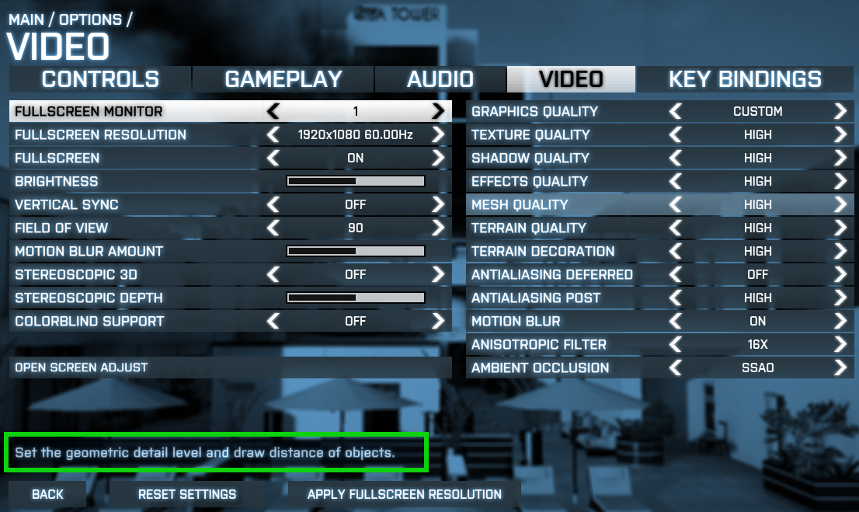

Figure 10. Description is marked with a green border. This border does not exist in the game but is added to the image.

The descriptions can be a simple repeat of the term used but without abbreviations (see Figure 11).

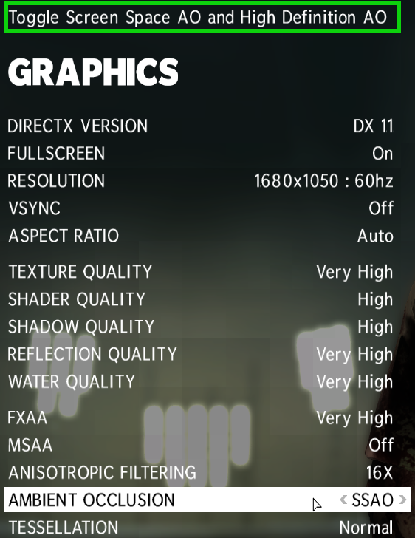

Figure 11. Description is marked with a green border. This border does not exists in the game but is added to the image.

Or it can be a description not only explaining the term but also what the different options of the setting will do (see Figure 12).

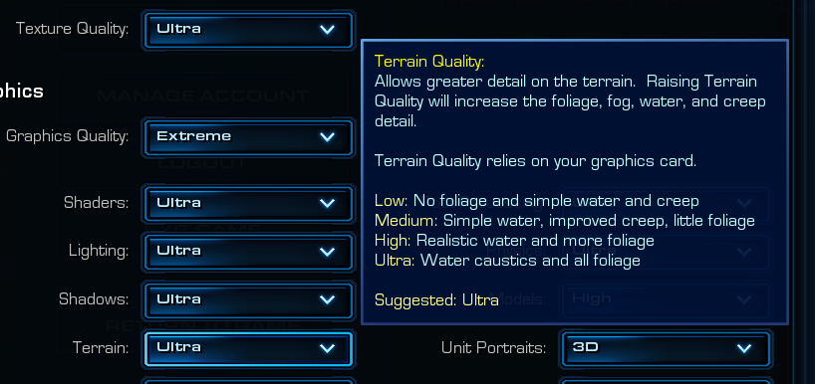

Figure 12. Image of Starcraft 2 SUI.

Some games SUI will even have a description that is even more confusing than the term itself (see Figure 13).

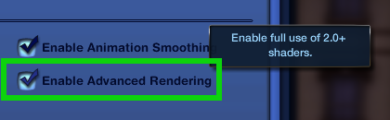

Figure 13. Green border does not exists in game. It is added to the image.

A well thought out description written in simpler terms would be of great benefit to a user who does not understand the setting. If this description includes what the implications are to the overall performance in the game it would help with problems related to bad performance as well.

Many settings, and almost all graphic settings, have an impact on a game’s performance. Increasing these settings means that the game can run with lower Frames Per Second (FPS) and having too low FPS will cause the game to run slower and stutter. How much of an impact this has on the game experience is dependent on what type of game and on the preferences of the user. Some genres require fast and fluid movement, such as First-Person Shooters, and suffer a lot from low FPS whereas other games are slower paced, such as turn-based strategy games, and too low FPS can go unnoticed. This also applies to the users preferences. Some gamers are greatly annoyed by too low FPS where others accept lower FPS to get better graphics, for example.

In this study we had problems testing settings tied to poor performance of the game. These problems are mostly technical. One of the two biggest problems were that we could not reliably force low performance in specific areas in the games we tested. The other big problem was that we could not record the test with low performance as the recording software used affected the performance to a greater degree when it was already low. This lead to the game being almost unplayable.

A future study looking into the effects of low performance on a users game experience would be very interesting. It could also combine looking into if the users understand what the impact on performance the different settings have. As the interview showed, some of the respondents changed Graphic settings with performance in mind, either to increase the settings to the max that their hardware would allow or lower them to get increased performance. This should mean that both performance and higher Graphics settings is important to at least some users.

Another, important, future study would be to look into how much wrongly set settings impact a users game experience. This study could also include the above mentioned study to see how low performance affects a game. The results from this kind of study would be very valuable as knowing how big of an impact settings has on a users game experience matters a lot. Combine the results with the current study and a game developer can get good data to help with deciding on how much time to actually spend developing the games SUI. As this study shows the Input and Sound settings seems to be understood by most so spending a lot of developing time for these might not be the best decision. Graphics settings, however, seems to be quite hard to understand but if a future study would show that playing a game with wrongly set graphics settings does not impact a users game experience spending developing time to solve this problem may be a waste of time. If it does impact the users game experience the developer should benefit from spending time to make the graphics settings easier to understand.

The terminology of a game’s SUI has been discussed a lot in this study and as the settings is almost always represented by terms this is natural. One thing that has not been discussed is the format of which the choices for a setting is presented and the impact this has on the understanding of them. The most common format is several choices that the user can scroll through but drop-down menus are quite common as well. The difference between these two formats is that one, drop-down menus, allow you to see all choices immediately whereas the other requires you to scroll through all the alternatives to do the same. This poses a practical limit on how many choices a setting like this can have. If it has too many it becomes tedious to scroll through them all and it can even be hard to remember them all when finally deciding what to set it to, specially if they are similar to each other.

There are many potential formats that could be used and looking into which one works best could be useful. The format of the settings are usually the same for all of them in a single game’s SUI as this keeps a overall design for the game. This, however, may not be the best way of doing it. Having different formats for the settings may be useful as some of them have vastly different choices. Many settings have choices presented as some arbitrary terms, such as: Low, Medium and High. Anti-Aliasing, for example, has something quite like this but usually use different terms where the terms relates to how many samplings this technique will do. This is usually presented as: 2x, 4x, 8x and 16x. The terms Low, Medium and High gives a user that does not fully understand the setting some kind of idea of what the actual alternative is whereas the terms 2x, 4x, etc does not. Using a slider, for example, as a format for the mentioned Anti-Aliasing setting could work just as well and be even better if it is presented as a slider with corresponding explaining text.

As already mentioned, the terms used for Graphics settings are often hard to understand. It has also been explained why this is: they represent complex, difficult to explain techniques. Sometimes this is also true for the alternatives for a setting although often they are presented with arbitrary scaled terms, such as Low to High.

Some games try to use easier to understand terms. Anti-Aliasing, for example, is sometimes  called Edge Smoothing or something similar. One problem with this is that Aliasing, the problem that the Anti-Aliasing tries to correct, does not exist outside of computers. Because of this it is hard to use a term that can be understood because theres no analogue in the real world.

# References

Bryman, A. (2011) *Samhällsvetenskapliga metoder.* (Andra upplagan) Solna: Liber AB

Csikszentmihalyi, M. (2008) *Flow: The Psychology of Optimal Experience*. New York, NY: Harper Perennial Modern Classics.

Dataspelsbranschen. (2006) *Försäljning av tv- och datorspel 2006*. Annual report from a trade organization. Available on the Internet:<http://www.dataspelsbranschen.se/media/1580/mdts-statistik%202006.pdf> [Downloaded 13.02.08].

Dataspelsbranschen. (2010 a) *Game sales in the Nordic 2010*. Annual report from a trade organization.

Available on the Internet: <http://www.dataspelsbranschen.se/media/117167/nordic%20game%20sales%202010%20screen.pdf> [Downloaded 13.04.25].

Dataspelsbranschen. (2011) *Nordic Game Sales 2011*. Annual report from a trade organization. Available on the Internet:<http://www.dataspelsbranschen.se/media/126293/eng.nordic%20game%20sales%202011.pdf> [Downloaded 13.02.08].

Ejvegård, R. (2012) *Vetenskaplig metod*. (4th edition) Lund: Studentlitteratur AB

*Game accessibility guidelines* 2013, accessed 15 march 2013. <<http://www.gameaccessibilityguidelines.com/>>

Gentner, D. & Stevens, A. (1983) *Mental Models.* Hillsdale, NJ: Lawrence Erlbaum Associates.

Gregory, Jason. (2009) *Game Engine Architecture*. Natick, MA: A K Peters.

Huizinga, Johann. (1955) *Homo Ludens: A Study of the Play Element in Culture*. Boston, MA: Beacon Press.

Interactive Software Federation of Europe. (2012) *Videogames in Europe: 2012 Consumer Study*. Consumer study from a trade organization. Available on the internet:<http://www.isfe.eu/sites/isfe.eu/files/attachments/euro_summary_-_isfe_consumer_study.pdf>

[Downloaded 13.04.26].

International Game Developers Associations special interest group Game Accessibility 2013, accessed 15 march 2013. <<http://igda-gasig.org/>>

Juul, J (2009). *A casual revolution.* Cambridge, MA; MIT Press.

Linderoth, J. (2011) Beyond the digital divide: An ecological approach to gameplay. *In: Proceedings of DiGRA 2011 Conference: Think Design Play, 14-17 September 2011, Hilversum, the Netherlands*. DiGRA/Utrecht School of the Arts, September, 2011.

Norman, D. (2002) *The design of everyday things.* New York, NY: Basic Books.

Norman, K (1991). *The Psychology of Menu Selection: Designing Cognitive Control at the Human/Computer Interface*. New York, NY: Ablax Publishing Corporation.

Preece, J, Rogers, Y & Sharp, H. (2009). *Interaction design: Beyond human-computer interaction.* (2nd edition) Chichester: John Wiley & Sons Ltd.

Rimmer, J & Wakeman, I. (1999). *Who helps the helpers: Technological change in the help*

*desk.* In K. Buckner (Ed.) *Ethnographic studies in real and virtual environments: Inhabited*

*information spaces and connected communities*. 24-26 January 1999 Edinburgh University.

P. 70-80.ISBN 1-902520-01-7.

Sheeran, L, Sasse, M.A, Rimmer, J. & Wakeman, I. (2002). *How Web Browsers Shape*

*Users’ Understanding of Networks*. The Electronic Library, Vol. 20(1) 35-42.

Sheffield, B. (2009) *DICE 09: NPD - Six Million New Gamers In Last Year.* Available on the Internet:<http://www.gamasutra.com/php-bin/news_index.php?story=22415#.UFr2dLIgf08> [Downloaded 13.04.25].

Rollings, A & Adams, E. (2003) *On Game Design*. Indianapolis, IN: New Riders.

Sheffield, B. (2009) *DICE 09: NPD - Six Million New Gamers In Last Year.* Available on the Internet:<http://www.gamasutra.com/php-bin/news_index.php?story=22415#.UFr2dLIgf08> [Downloaded 13.02.11].

Valve Corporation (2013). *Steam Hardware and Software Survey: August 2013*. Monthly Automatic Survey. Available on the Internet:<http://store.steampowered.com/hwsurvey> [Downloaded 13.02.08].

# Ludography

Blizzard Entertainment (2012). *Diablo 3*. Irvine, CA: Blizzard Entertainment.

Blizzard Entertainment (2010). *Starcraft 2: Wings of Liberty*. Irvine, CA: Blizzard Entertainment.

DICE (2011). *Battlefield 3*. (Version: release1.4-289). Redwood City, CA: Electronic Arts.

Io Interactive (2012). *Hitman: Absolution*. Tokyo: Square Enix.

Rockstar Studios (2012). *Max Payne 3*. New York, NY: Rockstar Games.

Stardock (2012). *Elemental: Fallen Enchantress*. Plymouth, MI: Stardock.

The Creative Assembly (). *Total War: Shogun 2*. Tokyo: Sega.

The Sims Studio (2010). *The Sims 3*. Redwood City, CA: Electronic Arts.

# Appendix

Appendix 1

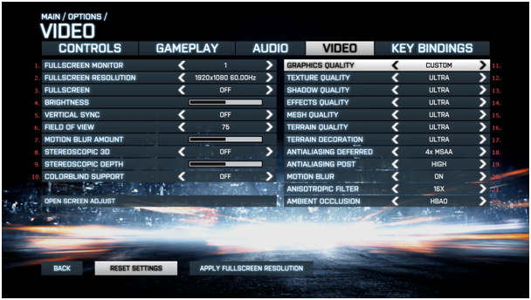

Figur 1 Battlefield 3 Graphics SUI.

This picture is of the SUI in Battlefield 3 (DICE, 2011) played on PC. As seen on the picture the SUI is divided into five categories named: Controls, Gameplay, Audio, Video, Key Bindings. The three last categories exists in almost all games as computer games are commonly audiovisual and requires some sort of input. The first two categories usually exists in games but can vary quite a bit in their content. Controls is a category that also handles the input but, unlike Key Bindings, it is more directed towards general settings like: mouse sensitivity, invert mouse movement, etc. It is not uncommon that Controls and Key Bindings exists in the same category and i. Furthermore it is also common for game specific input settings to end up in Controls. Gameplay is usually a category where most of the game specific settings are put. As the details of the actual gameplay varies between game it is only natural that these settings are put in this category.

A quick explanation of all the settings shown in Battlefield 3:

1. If you have several monitors this is a setting to choose which monitor the game will be run on.
2. The resolution the game is run in. The format is Width * Height and the value is in amount of Pixels. The second number is the update frequency the monitor should use, in the format of Hertz (Hz). The alternatives are those commonly supported by computers. Some games detect what alternatives your monitor can run and only supply these for the user.
3. If the game should be run in full-screen mode or not. The alternatives are simply On or Off.
4. Adjusts the brightness of the game. The further right the slider is the brighter the game is shown.
5. If the update frequency of the monitor should synchronize with the frames per second the computer runs the game in. Without this setting a user may get unwanted graphical bugs, called *tearing*.
6. How large the users field of view is. The value is in degrees.
7. The amount of blur applied when the player character travels fast.
8. If the game is rendered with a stereoscopic 3D effect. This requires specialized hardware. It works roughly the same as 3D glasses in a cinema.
9. The depth of this 3D effect.
10. Changes effects in the game so that they are understandable by people that are colorblind. These effects are usually notifications, alerts, etc. and not explosions, lightning effects, etc.
11. Graphical pre-sets. This setting has six different alternatives: low, medium, high, ultra, custom and auto. Low, medium, high and ultra are pre-defined sets that set all other settings to the corresponding value. Auto tries to evaluate the users hardware and then apply the correct settings. Custom is when the user can change the individual settings on his or her own. If anything but Custom is chosen individual settings can not be changed. The pre-defined sets are often not optimal and the Auto alternative does not always get the optimal settings correct.
12. The quality level of the textures, the surface image on objects, in the game.
13. The quality level of the shadows used in the game. What you choose is how exact the shadows should be drawn.
14. The quality level of in-game effects. These are graphical effects such as explosions, smoke, etc.
15. The quality level of the 3D models in the game. Simply put the higher the quality level the more surfaces the object have.
16. The quality level of the terrain in the game. Same as the above setting but only applied to the models representing the terrain.
17. How far away decorative details in the terrain should be shown. With higher values a user can see these details further away from the player character.
18. Anti-aliasing is a technique to smoothen edges on objects in the game world. This technique is fairly advanced and we will not go into great detail about it here. The alternatives for this, and the next, setting is in amount of passes and what type of algorithm to use. The difference between this setting and the next one is when in the rendering process this technique is applied.
19. See above.
20. If a blurring effect should be applied when the player character travels fast.
21. This is a technique with varied uses. The major one is to make sure textures is not distorted when looking at them from an extreme angle.
22. This is a setting for how to simulate light. The alternatives are Off, SSAO and HBAO. SSAO and HBAO are different ways to calculate this with HBAO being the more advanced, and requires more computational power, of the two.

When holding the mouse over each setting you get a short description of the setting as show in this picture.

[bild på BF3 SUI]

There are very few instances when the user gets informed of the implications the setting have of the performance. All the settings have an implication on the performance of the game. The higher the values of the settings the more computational power is required.